

**INT 301**

**OPEN SOURCE TECHNOLOGIES**

**CA3**

**Submitted to –**

**Dr. Manjot Kaur**

**Submitted by –**

**Aryan Soni**

**Reg. No. – 11915538**

**Roll No. – RKE016B64**

**1. Introduction**

* 1. **Objective of the project:**

The objective of this project is to use desired Open Source Software list all the security updates missing in your Window OS. Also, list all free system information about the hardware and software installed.

**1.2 Description of the project:**

The project involves using open-source software to provide a detailed report of the hardware and software components installed on a computer. Its main motive is to provide users with an accurate inventory of their computer's components, including the operating system, processor, memory, storage devices, network adapters, and installed software.

**1.3 Scope of the project:**

The scope of project is limited to providing information about the computer on which it is installed. It does not provide any features for optimizing or managing the system, nor does it offer any troubleshooting assistance. Instead, it provides a comprehensive report on the computer's configuration, which can be useful for IT professionals, system administrators, and home users who want to have a better understanding of their system's capabilities and status.

**2. System Description**

**2.1 Target system description:**

In this project we use open source software which is Belarc Advisor, it is a computer software program designed to generate detailed reports about your computer system. This report contains information about system's hardware and software components, as well as security and performance related information.  
  
A typical target system description that can be generated by Belarc Advisor includes:  
Operating system: The operating system version and edition installed on the system, and any service packs or updates installed.

* CPU: The model and clock frequency of the central processing unit (CPU) installed in the system.
* Memory: Amount of physical random access memory (RAM) installed on the system.
* Storage: Total amount of storage space available on the system, including details about hard drives and external storage devices attached to the system.
* Graphic: The model and specifications of the graphics card installed in your system.
* Communication network: Information about network adapters and connections available in the system, including IP and MAC addresses.
* Software: A comprehensive list of all software applications installed on your system, including version numbers and license information.
* Safety: Information about the system's security status, such as installed antivirus software, firewalls, and the presence of security patches. Overall, the target system description generated by Belarc Advisor provides a detailed and comprehensive overview of your computer system, making it a useful tool for troubleshooting, maintenance, and system administration.

**2.2 Assumptions and Dependencies:**

**Assumptions:**

* A supported operating system is running on the system being analysed. Belarc Advisor supports various versions of Windows and some versions of Linux.
* The user running the Belarc Advisor software has the necessary privileges to scan the system and access the information required to generate reports.
* The systems analysed are connected to the Internet, as some of the information contained in the reports may require access to online databases.

**Dependencies:**

* The accuracy of reports generated by Belarc Advisor depends on the accuracy and completeness of the information collected by the system.
* Belarc Advisor relies on various software components and libraries to collect and process the required information. The proper functioning of these components is necessary for the proper functioning of the tool.
* The performance of the analysed system can affect the time it takes Belarc Advisor to complete the scan and generate the report. A slow or overloaded system can lead to long scan times and slow reporting.

**3. Analysis Report**

**3.1 System Snapshots and Full Analysis Report:**

On installing the software, it requests the access for permissions of the system and runs the software as an administrator.

After a successful run, it provides detailed overview of the system along with computer profile summary and missing security updates required in the system.

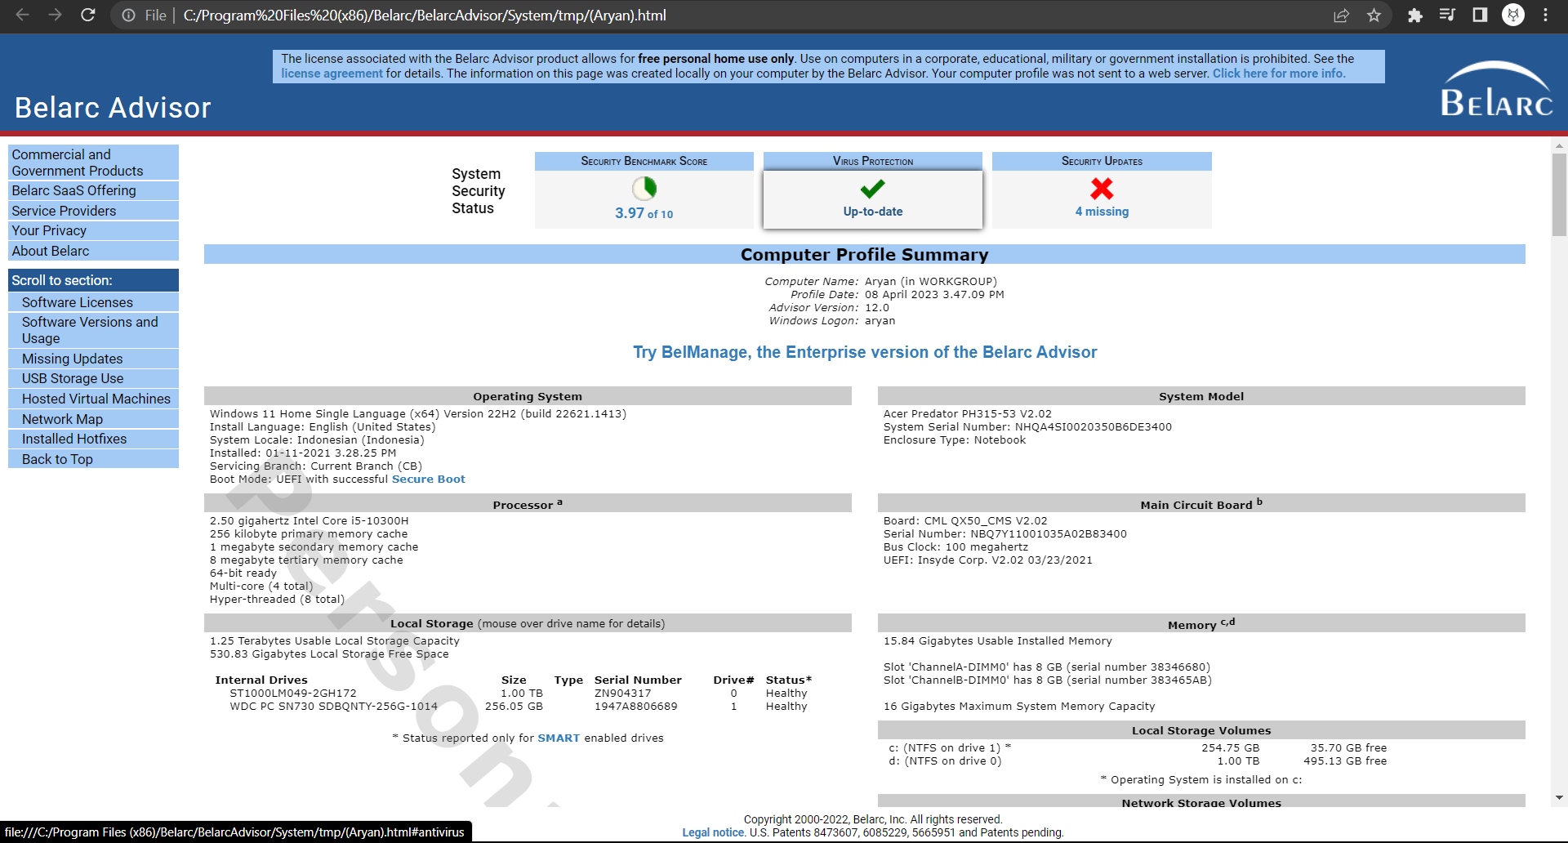

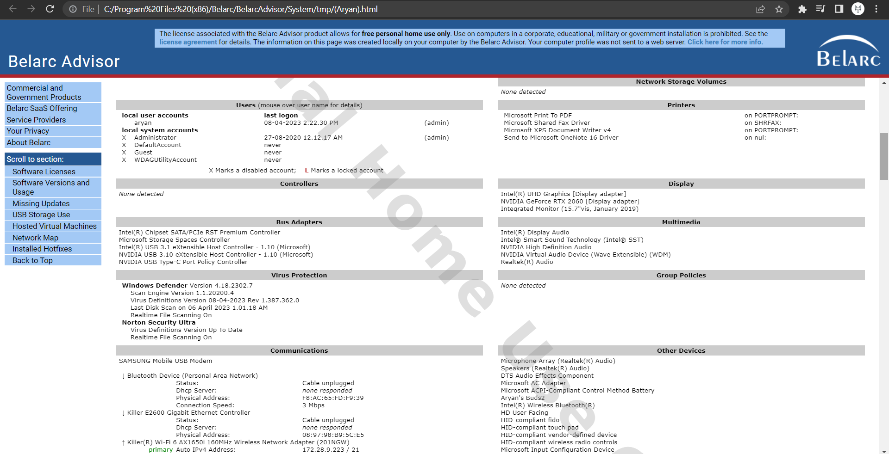

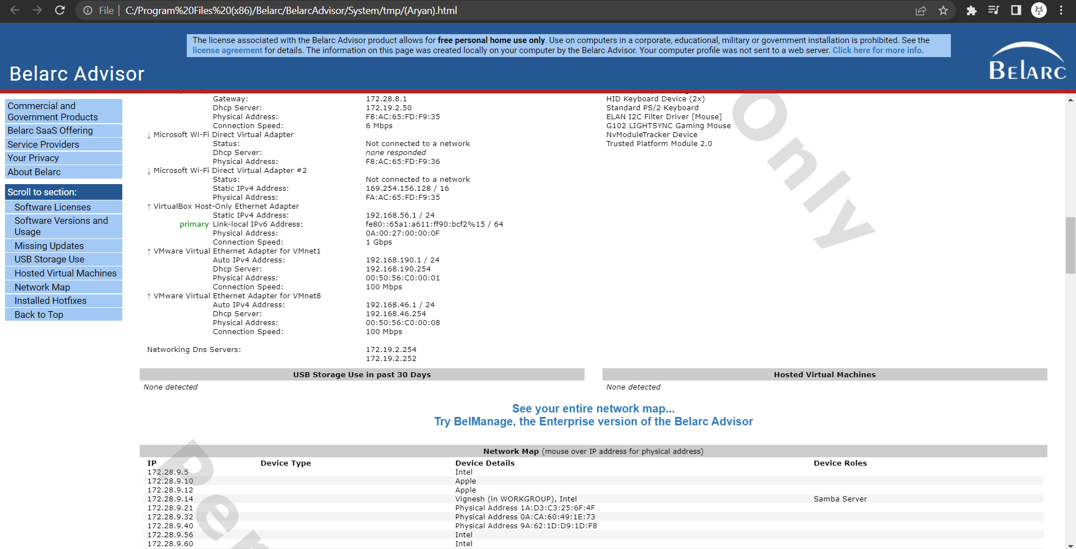

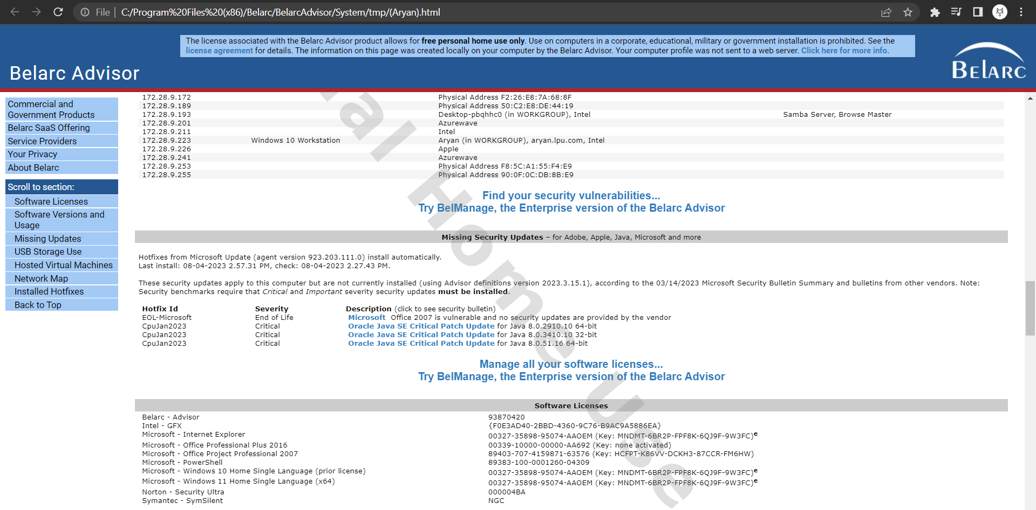

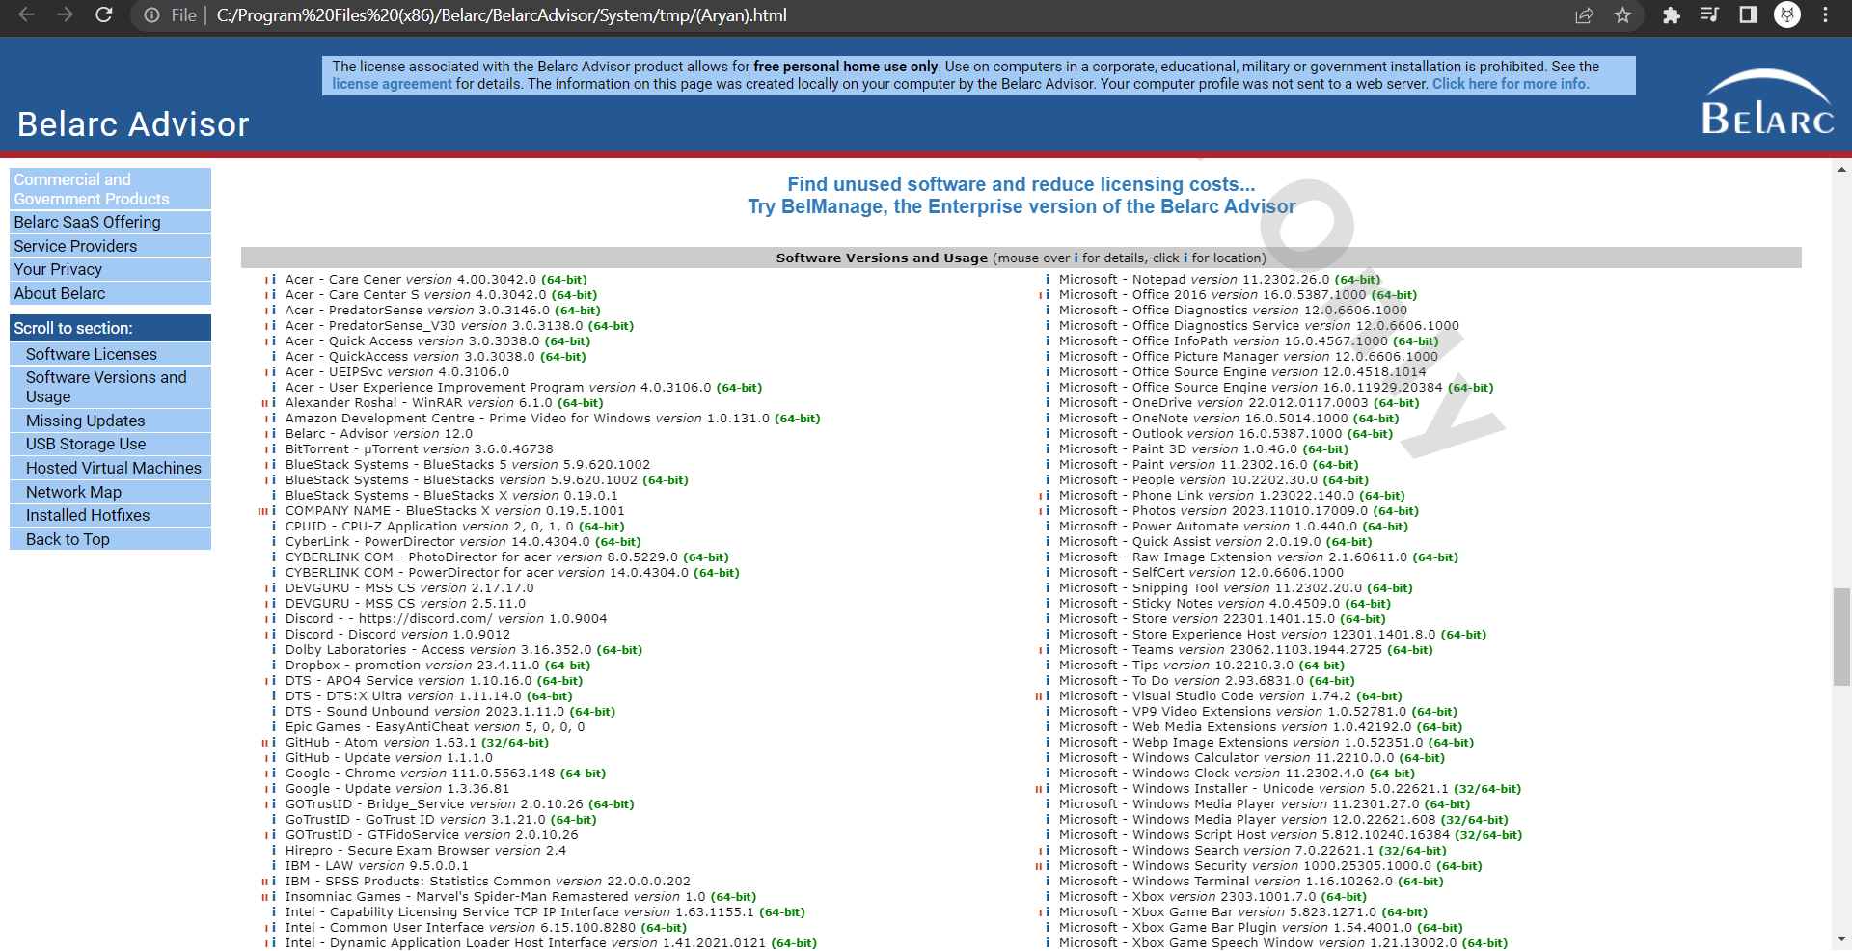

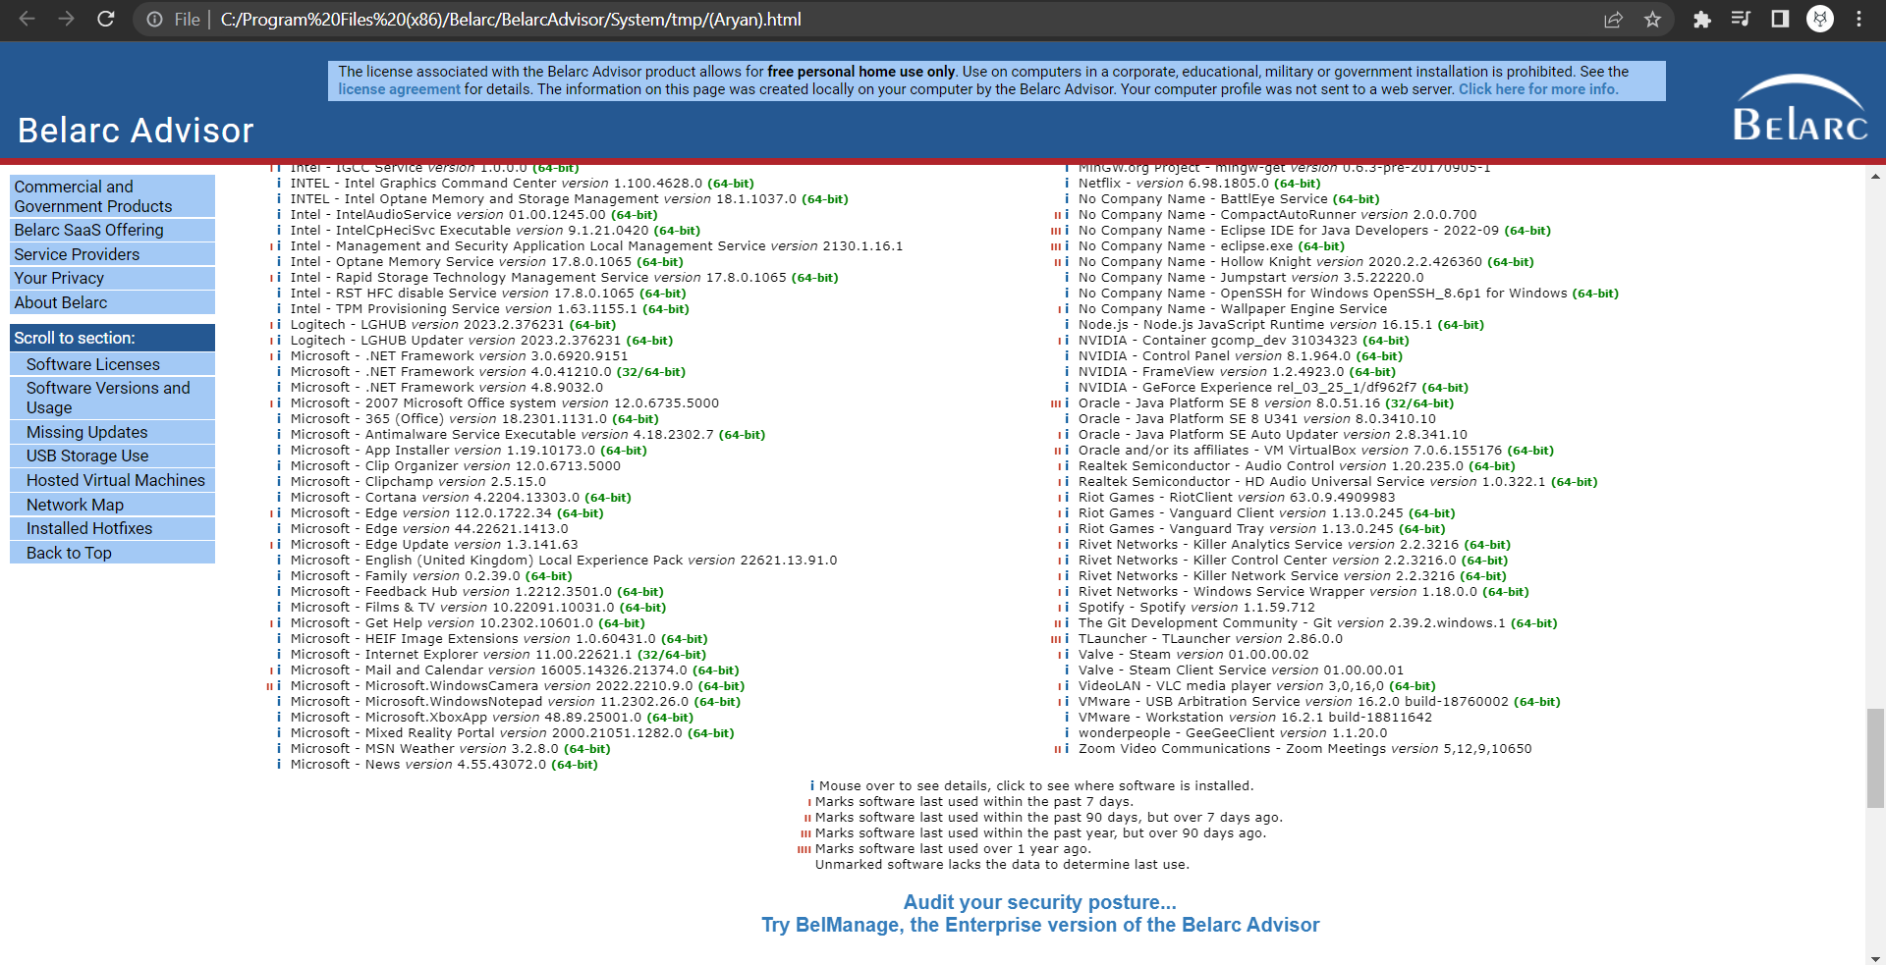

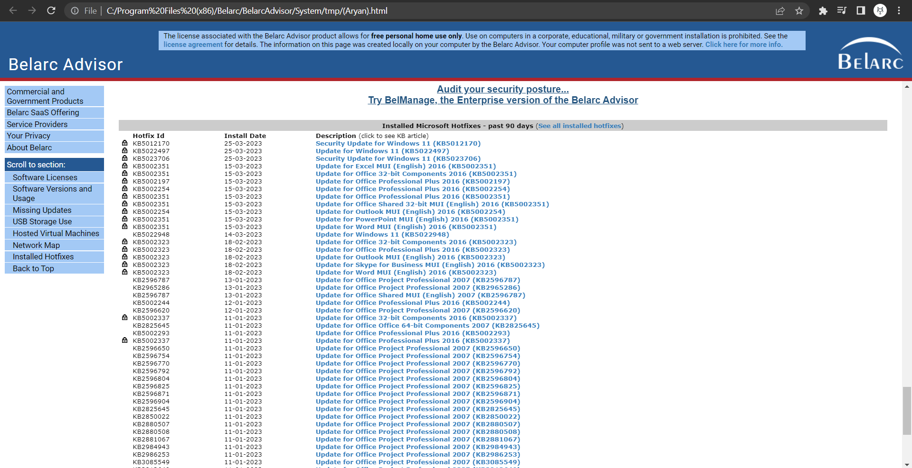

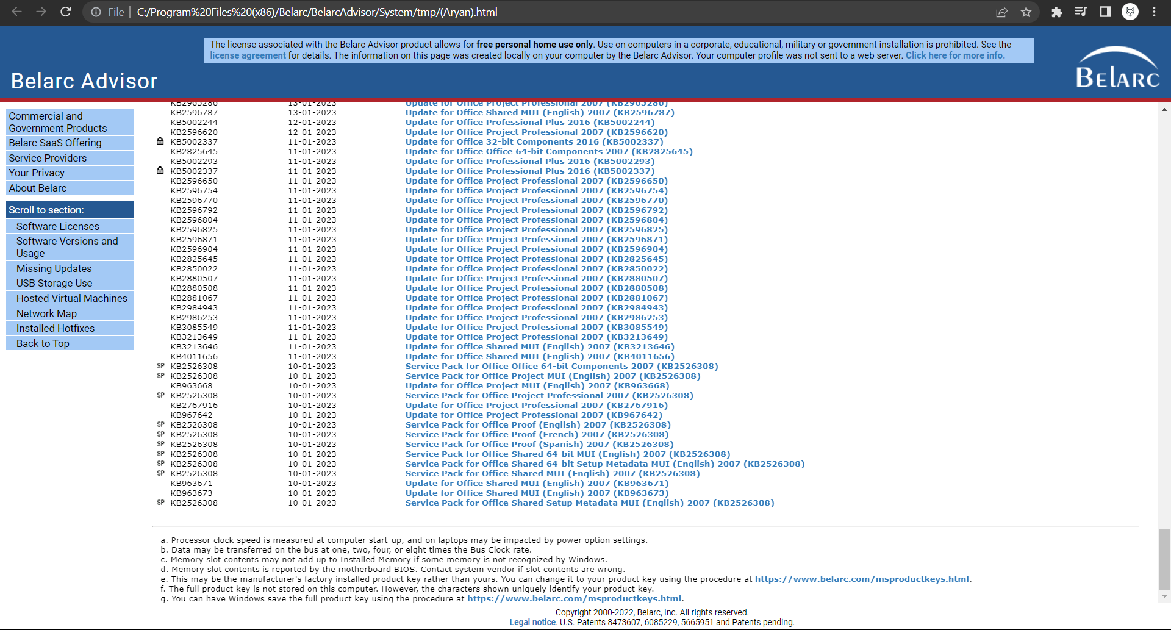

**4. Reference/ Bibliography**

Official website of Berark Advisor:

Belarc Advisor's official website provides a wealth of information about the tool, including features, system requirements, and usage <https://belarc.com/products/belarc-advisor>

Technical goal:  
TechTarget is a website that provides information and resources for IT professionals with <https://searchitchannel.techtarget.com/definition/Belarc-Advisor>

TechRepublic:  
TechRepublic is a website that provides news, analysis and advice for IT professionals

<https://www.techrepublic.com/article/troubleshoot-computer-problems-with-belarc-advisor/>

CNET:  
CNET is a website that provides technology product reviews, news, and downloads. You can access the page with

<https://download.cnet.com/Belarc-Advisor/3000-2094_4-10007277.html>

PC magazine:  
PCMag is a website that provides technology product reviews and recommendations. You can access the page with

<https://www.pcmag.com/reviews/belarc-advisor>